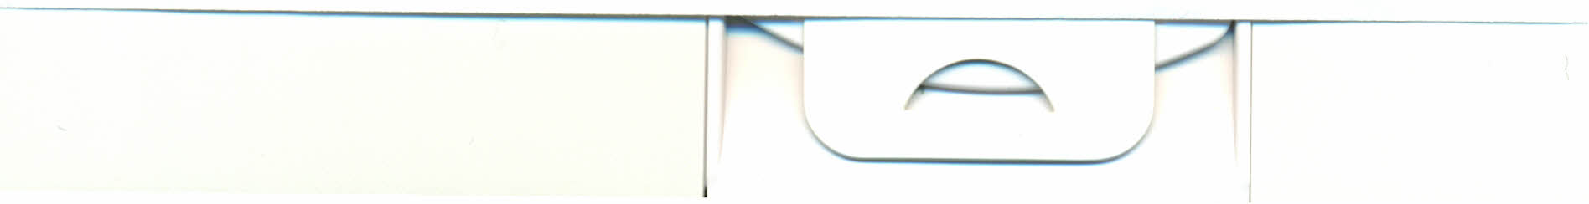
AMERICAN COUNCIL OF THE
BLIND OF NEBRASKA:
TELEPHONE CONFERENCE
JUNE 15TH, 2011 7:30 PM

MEETING CALLED TO ORDER BY PRESIDENT JIM JIRAK

MINUTES READ BY ANN PELIKAN: ACCEPTED

Howard COMPTON GAVE TREASURE REPORT: ACCEPTED:

NEW BUSINESS:

(1) FREMONT PROBLEM: ALL AGREED TO LET THIS SIT FOR A WHILE AND WATCH WHAT IS GOING ON WITH IT. FURTHER INFORMATION NEEDED.
(2) WORLD HAROLD: NO INTEREST
(3)BOARD INSURANCE: AGREED TO GET THIS PROTECTION FOR $1,400 A
MONTH.

(4.) COMMISSIONERS MEETING: AUGUST, 6TH IN YORK. MEETING PLACE TO BE ANNOUNCED AT A LATER DATE. DINNER WILL BE AT JULIE'S.
(2) JIM SAID THAT HE WAS GOING TO SEEK HIS SEAT ON THE BOARD. HE TOLD US THAT ANN SIGNED A RECOMMENDATION LETTER FOR HIM AND HE WILL SEND IT IN TODAY, JUNE 16TH.

TRANSPORTATION:
A MOTION WAS MADE TO PAY MILEAGE OF $.51 AND DRIVE TIME OF UP TO $10.00 PER HOUR TO THE DRIVER. THIS MOTION WAS CARRIED AND GOES INTO EFFECT ASAP:


THE PLACE THAT THE 2012 CONFERENCE WILL BE HELD WAS DISCUSSED IN DEPTH AND THE DIVOT CONFERENCE AND LODGE WAS THE #1 VOTE GETTER WITH THE STIPULATION THAT JIM NOT SIGN THE CONTRACT IF WE CAN'T GET FOOD AND DRINK IN. FREMONT'S WILDERNESS LODGE IS THE 2ND CHOICE. IF WE DON'T GET WHAT WE WANT IN NORFOLK THEN WE WILL BE IN FREMONT. THIS WILL BE KNOWN SOON AND ALL WILL BE NOTIFIED

OLD BUSINESS:

(1) STATUS OF DIRECT BILL CAR RENTAL: DISMISSED.
(2)ATTORNEY GENERAL LETTER: WAITING FOR LAW SUIT TO BE OVER BEFORE FURTHER ACTION TO BE TAKEN.

MIDWEST LEADERSHIP TRAINING.
(1) STATE WILL PAY FOR VAN RENTAL AND DRIVER EXPENSES. THIS WAS DECIDED IN THE JANUARY MEETING.
(2) DISCUSSION ON SENDING A MEMBER OF THE BOARD THROUGH THE TRAINING. A MOTION WAS MADE TO SEND ANN PELIKAN BY BARBARA EPWORTH AND 2ND BY HOWARD COMPTON. MOTION CARRIED.
I WOULD LIKE TO THANK THE BOARD FOR its CONFIDENCE IN ME ON THIS MATTER.
MOTION MADE TO ADJOURN BY MARK BULGER 2ND BY JIM JIRAK. ALL IN FAVOR MOTION CARRIED. THIS MEETING WAS
ADJOURNED AT 9:50 PM.
MINUTES SUBMITTED RESPECTFULLY

There were ten (10)
Members attending:
Jim Jirak, President
Glendora Weiland, Vice-President
Howard Compton, Treasurer
Mark Bulger, Membership
Barbara Epworth, State Rep
Ann Pelikan, Recording Secretary
Janice Shafer, Corresponding Secretary
Terry Brennfoerder, Lincoln Chapter President
Bob Riley, Fremont Chapter President
Paulette Monthei, Consultant

