American Council of the Blind of Nebraska
50 Years of Honoring Our Past
& Empowering Our Future
April 17 & 18, 2026
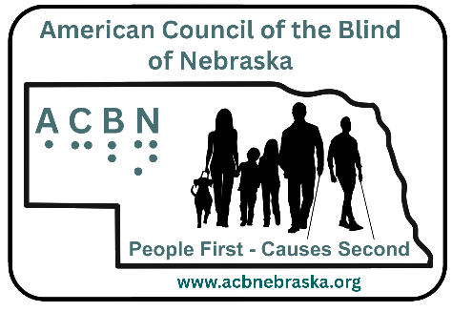

INTRODUCTION
As the American Council of the Blind of Nebraska (ACBN) marks its 50th anniversary, we pause to celebrate a remarkable legacy of advocacy, resilience, and community. For five decades, Nebraskans who are blind or visually impaired, along with their allies, have worked tirelessly to advance opportunity, accessibility, and independence across the state. This milestone is not only a reflection of years passed, but of lives changed, barriers broken, and a shared commitment to ensuring that all individuals can participate fully and equally in society.

Happy 50th anniversary, ACBN! As we honor our past, we also look forward with purpose and determination. The foundation laid by those who came before us continues to inspire new generations of leaders and advocates. Together, we celebrate the progress achieved and renew our commitment to empowering the future—one defined by inclusion, innovation, and unwavering advocacy for all. Here’s to 50 years of vision, courage, and community—and to celebrating this incredible milestone together with joy, pride, and excitement for all that lies ahead!

To make our 50th anniversary even more memorable, we’re inviting you to join the excitement of our nationwide auction on 32Auctions! Celebrate with us by bidding on fun and unique items like a Lego braille set, a donut gift basket, an air fryer, a Ski for Light trip, and much more—all while supporting ACBN’s mission of empowerment and inclusion. Bidding begins at 12:00 a.m. Central on April 11 and closes at 7:10 p.m. Central on April 18. Visit www.32auctions.com/acbn2026 to join the fun and be part of this milestone celebration!

Kristal Platt
President
Omaha, NE

HOTEL INFORMATION:
Holiday Inn Downtown Waterpark
1420 Cuming St
Omaha NE 68102
402-341-0124

Hotel Details
An 8-minute walk from baseball games at Charles Schwab Field Omaha, this casual hotel is also 1 mile from the Joslyn Art Museum and 4 miles from Omaha's Henry Doorly Zoo and Aquarium. Unassuming rooms come with Wi-Fi and flat-screen TVs, as well as minifridges, microwaves and coffee makers. Suites add kitchenettes, whirlpool tubs and/or pull-out sofas.

Amenities include a casual restaurant, an area shuttle and an indoor water park, as well as a meeting room and a ballroom. An exercise room and a business center are both open 24/7. It also offers a paid breakfast and an indoor pool.

Parking is available at $15 per day through a 3rd party company. There is a QR code for use, and the front desk can also assist guests with that need to scan it and enter their information. There are a few free, and metered spots available if someone would prefer not to pay the full daily fee. The hotel also offers free Wi-Fi with the password being OMAFC. Please note the password is in all caps. And all meetings are taking place in the Bacardi.

For guests traveling with service animals, the best area to relieve them is by using the exit that goes to the parking lot on the backside/North of the hotel, there is a grass area towards the right of the parking lot. There are trashcans outside of that hotel exit/entrance for waste disposal. The best entrance or exit is the one attached to the parking lot.

2026 CONVENTION AGENDA
50 Years of Honoring Our Past & Empowering Our Future

Friday, April 17

8:00 a.m.
Registration

8:30 a.m.
Welcome, including invocation, presentation of colors, and group introductions
Kristal Platt, President
Omaha, NE

9:00 a.m.
The Job Search: Navigating Employment Opportunities as a Visually Impaired Job Seeker

Brent Heyen, General Manager, Country Inn & Suites
Board Chair, NCBVI
Lincoln, NE

Sania Kellogg, Braille Instructor, NCBVI
Lincoln, NE

Samantha Randall, Receptionist Downtown Omaha Hyatt Place
Omaha, NE

Oscar Gonzalez, On Air Talent; Production
Omaha, NE

Robert Sentelle, Estimator (currently in OJT)
Omaha, NE

9:45 a.m.
Break

10:00 a.m.
How to Get Social Security Benefits, Go to Work… and Live to Tell About It

Michael Dalto, President
High Note Consulting, LLC
Baltimore, MD

Here is your chance to get answers to your questions about Social Security Disability Insurance (SSDI) and Supplemental Security Income (SSI). The session will cover:
- What each benefit is and who is eligible
- Financial limits
- Benefit amounts
- Medical benefits that come with SSDI and SSI
- How to apply
- How work affects SSDI and SSI, and how to use safety nets called “work incentives” that help protect benefits when you work
- Advantages in the rules for blind people

Advanced sign up of 30-minute private consultations to discuss individual concerns after lunch is strongly encouraged. Read more at https://acbnebraska.org/michael-dalto-consults

12:00 p.m.
Boxed Lunch

1:00 p.m. to 3:00 p.m.
Exhibit Hall
Visit exhibitors as they display the latest technological advances.

3:00 p.m.
Break

3:15 p.m.
Involvement in Community Organizations as a Blind Person
Community involvement as a blind person: challenges, successes, and strategies for inclusive participation.

Amber Steet
Omaha, NE

4:00 p.m.
ACB Reports: What’s happening in Washington

An overview of how federal decisions affect state services, funding, and access; strategies for coalition building with other disability organizations; and ways members can engage effectively with lawmakers.

Rachel Schroeder
Springfield, IL
ACB Board of Directors

5:00 p.m.
Dinner on your own

6:30 p.m.
Recreation Zone

6:30 – 7:30 p.m.: Explore accessible games: DIY braille alphabet Lego, large yard games, and accessible board games

7:30 pm – 8:30 pm: Taiko Drumming Workshop

8:30 pm – 9:00 pm: Taiko Drumming Performance

Saturday, April 18

8:00 a.m.
Registration

8:30 a.m.
Welcome, including invocation, presentation of colors, and group introductions

Kristal Platt, President
Omaha, NE

Presentation of Colors

Offutt Air Force Base Honor Guard Bellevue, NE

8:50 a.m.
Beyond a Diagnosis

A diagnosis of any type often leads to anger, depression, and isolation. This session explores pathways toward renewed purpose and unexpected opportunities.

Daryl Kucera, CPT, MSAS
Fitness Science
Omaha, NE

9:20 a.m.
Change Your Story; Change Your Life

Our inner narrative and interpretation of the struggles and the challenges we have faced determines our resilience or our failings.

Dexter Thomas, President
Christian Record Services, Inc.
Lincoln, NE

9:50 a.m.
Break

10:00 a.m. to 12:00 p.m.
Exhibit Hall
Visit exhibitors as they display the latest technological advances.

12:00 p.m.
Boxed Lunch

1:00 p.m.
Financially Speaking
A look at financial planning, strategies for increasing retirement income, and how to avoid scams.

Mo Carpenter
Host, Money Matters with Mo
West Des Moines, IA

2:45 p.m.
Break

3:00 p.m.
The Differences Consumer Group Organizations Can Provide in the Rehabilitative Arena

Carlos Servan, Executive Director
NCBVI
Lincoln, NE

3:30 p.m.
Bringing Audio Description Back to Radio Talking Book Services and Advancements in Technology and Programming

Bekah Jerde, Executive Director
Radio Talking Book Services, Inc.
Omaha, NE

Stephanie Patzer, Communications Director
Radio Talking Book Services, Inc.
Omaha, NE

4:30 p.m.
Business Meeting

5:30 p.m.
Adjourn until banquet

6:00 p.m.
Banquet Social

6:30 p.m.
Opening and Invocation by Mark Bulger
Immediate Past President,
American Council of the Blind of Nebraska
Omaha, NE

Dinner

7:10 p.m.
Auction via 32Auctions
32Auctions bidding closes at 7:10 p.m. Central on April 18.

7:30 PM Banquet Welcome by Kristal Platt
President, American Council of the Blind of Nebraska
Omaha, NE

Recognition of 2025 Braille Institute Teacher of the Year, Audrey Graves

50th Anniversary Celebration Video

Awarding of Nebraska Life Memberships

Keynote Address by Rachel Schroeder
American Council of the Blind Board of Directors
Springfield, IL

Closing

LIST OF EXHIBITS
Friday only:

Assistive Technology Partnership
Technology with a Purpose! Connecting people with technology since 1989.

JRoss Tech
Provides adaptive technology setup, support, customization, and training to individuals, businesses and schools, to meet the personal, employment, or educational goals of individuals who are blind or visually impaired.

Nebraska Foundation for Visually Impaired Children
Is a non-profit organization founded in 1960 to meet needs of blind and visually impaired Nebraska schoolchildren that were not being met through school system or government programs. Over the years, they have supported a wide-range of activities that benefit these children.

Outlook Nebraska
Emerged in 2000 as a 501(c)(3) social enterprise determined to create a thriving workplace for the blind and visually impaired in our local community. Starting with just four blind associates producing paper products, we have grown into the largest employer of blind and visually impaired individuals in the state.

Saturday only:

Blind Lego Lady
Displaying depicted art using the Lego mosaic maker

Nebraska Lions Foundation
Supports vision and hearing programs across Nebraska, provides humanitarian services, assists local Lions Clubs in delivering community-based service projects and improves quality of life through screening, prevention, and early detection programs.

Nebraska Center for the Education of Children who are Blind & Visually Impaired
NCECBVI impacts student learning through communication, accountability, and leadership.

Friday & Saturday:

American Council of the Blind of Nebraska
For 50 years, the American Council of the Blind of Nebraska has championed the rights, independence, and dignity of individuals who are blind or visually impaired. Through comprehensive education, advocacy, and support, the organization has connected consumers to essential services and resources while fostering a strong and resilient community. As ACBN celebrates this golden anniversary, it honors a legacy of meaningful impact and renews its commitment to ensuring equity, access, and opportunity for generations to come.

Bus Across Nebraska
Offers an opportunity to the blind, visually impaired and physically challenged individuals to travel to the week-long Black Hills Regional Ski for Light annual winter event in Deadwood, SD each year in January!

Christian Record Services
Values the blind and low-vision community and are committed to enriching their life journeys through free inspirational, educational, and informational resources and experiences.

jw.org
Jehovah’s Witnesses are a global religious association. They are Christians who believe that Jesus Christ is the Son of God and our Savior.

Nanopac
Is a full-service assistive technology provider – based in Tulsa, Oklahoma, serving the region since 1987. They provide products and services that are suited for various individuals such as low vision, blindness, deaf, quadriplegia, hard of hearing, reading disabilities, and more.

Radio Talking Book Service, Inc.
Connects individuals who are blind, low vision, or print impaired to news, information, arts, and culture through the human voice and technology.

Share A Fare
Provides a transportation subsidy program affording blind & visually impaired residents the opportunity to be active participants in their community.

THANK YOU, SPONSORS!
We wish to thank our 2026 Convention Sponsors for their generous support.

Bronze ($50)
$50, NFVIC
The Nebraska Foundation for Visually Impaired Children is a non-profit organization founded in 1960 to meet needs of blind and visually impaired Nebraska schoolchildren that were not being met through school system or government programs. Over the years, we have supported a wide-range of activities that benefit these children.

Silver ($100)
$100, Columbus Noon Lions Club
The Columbus Noon Lions is 42 members strong. The club was chartered in 1921 and has a rich history of serving the people of the Columbus area. Our Club is very pleased to be able to celebrate this very special occasion.

$105, NanoPac
NanoPac Inc. is a full-service assistive technology provider based in Tulsa, Oklahoma, we have been serving our region since 1987. We provide products and services that are suited for various individuals such as low vision, blindness, deaf, quadriplegia, hard of hearing, reading disabilities, and more.

$100, Omaha Sunrise Lions
The Omaha Sunrise Lions offers Eyeglass & Hearing Aid Recycling, and Sight & Hearing Conservation. Members fundraise to support the Lions’ mission. In addition, they offer Nebraska Lions Foundation Mobile Screening Unit Support. Omaha Sunrise Lions congratulate the American Council of the Blind of Nebraska and celebrate with its three members who are leaders in both organizations.

$100, Westside Lions Club
Lions have a dynamic history. Founded in 1917, we are best known for fighting blindness, but we also volunteer for many different kinds of community projects - including caring for the environment, feeding the hungry and aiding seniors and those who are disabled.

Gold ($250)
$250, Assistive Technology Partnership
Technology with a Purpose — Connecting people with technology since 1989.

$250, Lincoln Star City Lions Club
Serving the Lincoln Community since 1987
"Together we can! Together we will!"
The Lions Club selected major focuses for humanitarian assistance locally and globally. We don't stop there but reach out into the community to extend our hand with numerous service projects. Our Clubs also provide assistance for hearing aids and eyeglasses.

Platinum ($500)
$500, Kristal Platt
Congratulating American Council of the Blind of Nebraska on
“50 Years of Honoring Our Past & Empowering Our Future”
Kristal Platt, President
American Council of the Blind of Nebraska
https://acbnebraska.org

Diamond ($1,000)
$1,000, Outlook Nebraska
Outlook Nebraska emerged in 2000 as a 501(c)(3) social enterprise determined to create a thriving workplace for the blind and visually impaired in our local community. Starting with just four blind associates producing paper products, we have grown into the largest employer of blind and visually impaired individuals in the state.

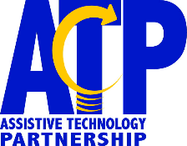
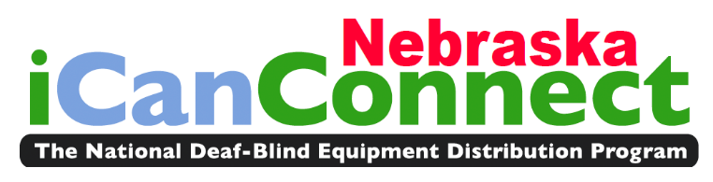
The iCanConnect Program (iCC) is also known as the National Deaf-Blind Equipment Distribution Program. Each state has their own iCC program and in Nebraska it is coordinated by the Assistive Technology Partnership (ATP). The iCC program provides free telecommunication equipment and training of that equipment to low-income individuals who are deaf-blind. Examples of telecommunication equipment provided by the program could include an amplified phone, smartphone, braille display, computer, magnification software, signaling device, etc. Additional information, including eligibility guidelines and applications for the Nebraska iCC program, can be found at www.icanconnect.org/how-to-apply/nebraska. To learn more about ATP you can visit our website at atp.nebraska.gov.
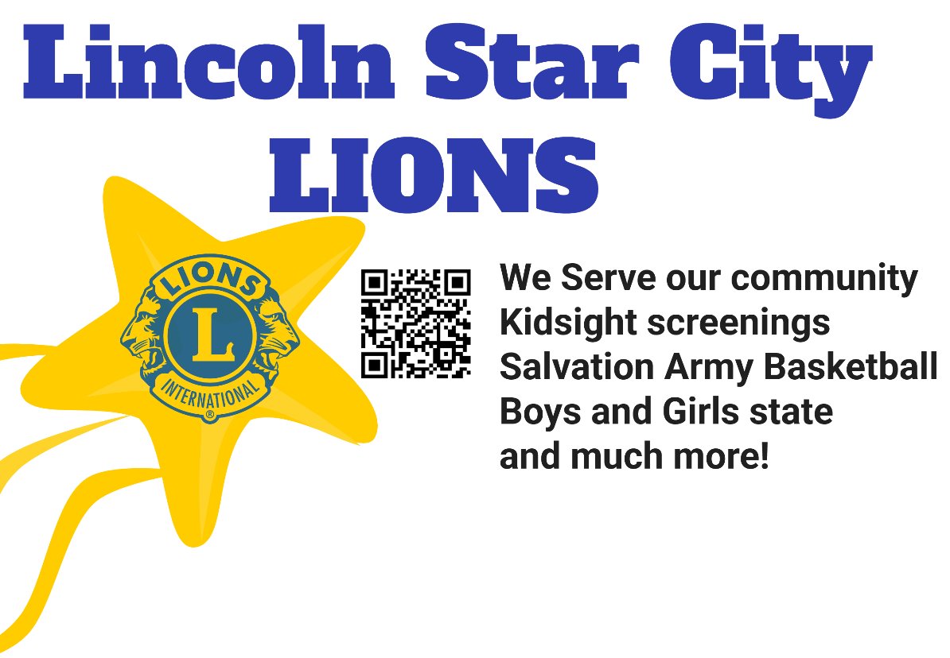

Image Description: Lincoln Star City Lions. We serve our community. Kidsight screenings. Salvation Army Basketball. Boys and Girls state and much more! Yellow star with Lions international logo.
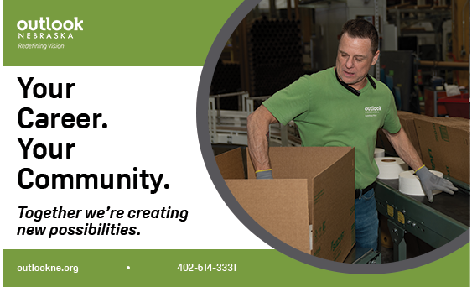

Image description: Outlook Nebraska – Redefining Vision.
Your Career. Your Community. Together we’re creating new possibilities. Outlookne.org - 402-614-3331
Image of man working in a factory setting.

Congratulating American Council of the Blind of Nebraska on
“50 Years of Honoring Our Past &
Empowering Our Future”

Kristal Platt, President
American Council of the Blind of Nebraska
https://acbnebraska.org

